|  |  |  |  |
| --- | --- | --- | --- |
| 1 | | 9,557 | |
| **NUMERO DE FRONTERAS** | | **ENERGIA AGREGADA** | |
|  | | | |
| 3,299,021 | 17 | | 162,695 |
| INGRESO 2021 | DÍAS CERTIFICADOS 2021 | | ENERGIA RESPALDADA 2021 |

**HISTORICO REINTEGRO DDV**

|  |  |
| --- | --- |
|  | **2021** |
| **ENE** | - |
| **FEB** | - |
| **MAR** | - |
| **ABR** | - |
| **MAY** | - |
| **JUN** | - |
| **JUL** | - |
| **AGO** | - |
| **SEP** | - |
| **OCT** | 3.3 |
| **NOV** | - |
| **DIC** | - |

**Los valores de la tabla están en millones de COP**

**REINTEGRO MECANISMO DDV OCTUBRE 2021**

|  |  |  |  |  |  |
| --- | --- | --- | --- | --- | --- |
| FECHA | TIPO DIA | CANTIDADES RESPALDO | PRECIO PONDERADO USD | TRM | PNETO |
| 2021-10-06 | Miércoles | 9,405 | 5.98 | 3,784.44 | 190,708 |
| 2021-10-11 | Lunes | 9,645 | 5.98 | 3,784.44 | 195,575 |
| 2021-10-12 | Martes | 9,647 | 5.98 | 3,784.44 | 195,615 |
| 2021-10-17 | Domingo - Festivo | 9,647 | 5.98 | 3,784.44 | 195,615 |
| 2021-10-18 | Domingo - Festivo | 9,645 | 5.98 | 3,784.44 | 195,575 |
| 2021-10-19 | Martes | 9,645 | 5.98 | 3,784.44 | 195,575 |
| 2021-10-20 | Miércoles | 9,503 | 5.98 | 3,784.44 | 192,695 |
| 2021-10-21 | Jueves | 9,503 | 5.98 | 3,784.44 | 192,695 |
| 2021-10-22 | Viernes | 9,383 | 5.98 | 3,784.44 | 190,262 |
| 2021-10-23 | Sábado | 9,455 | 5.98 | 3,784.44 | 191,722 |
| 2021-10-24 | Domingo - Festivo | 9,647 | 5.98 | 3,784.44 | 195,615 |
| 2021-10-25 | Lunes | 9,647 | 5.98 | 3,784.44 | 195,615 |
| 2021-10-26 | Martes | 9,479 | 5.98 | 3,784.44 | 192,209 |
| 2021-10-27 | Miércoles | 9,647 | 5.98 | 3,784.44 | 195,615 |
| 2021-10-28 | Jueves | 9,647 | 5.98 | 3,784.44 | 195,615 |
| 2021-10-29 | Viernes | 9,647 | 5.98 | 3,784.44 | 195,615 |
| 2021-10-30 | Sábado | 9,503 | 5.98 | 3,784.44 | 192,695 |

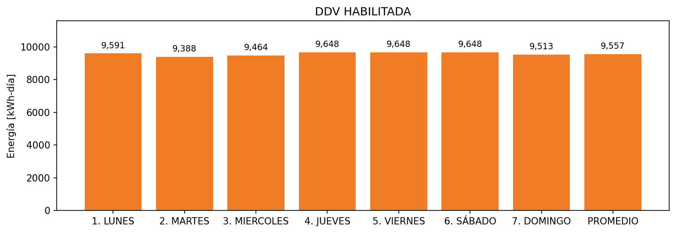

|  |  |  |  |  |  |  |  |  |  |
| --- | --- | --- | --- | --- | --- | --- | --- | --- | --- |
| **FRONTERA** | **COD SIC** | **FRT DDV** | **TIPO DDV** | **PROMEDIO** | **PRÓXIMA ACTUALIZACIÓN** | **MARGEN DE ERROR** | **ÚLTIMA PRUEBA DDV** | **DÍAS PARTICIPACIÓN** | **FECHA REFERENCIA PRÓXIMA PRUEBA DDV** |
| HOTEL ALMIRANTE CARTAGENA COLOMBIA | Frt00433 | Frt43098 | LBC | 9,557 | 2022-01-19 | 2,71 | 2021-09-23 | 17.0 | 2022-02-20 |